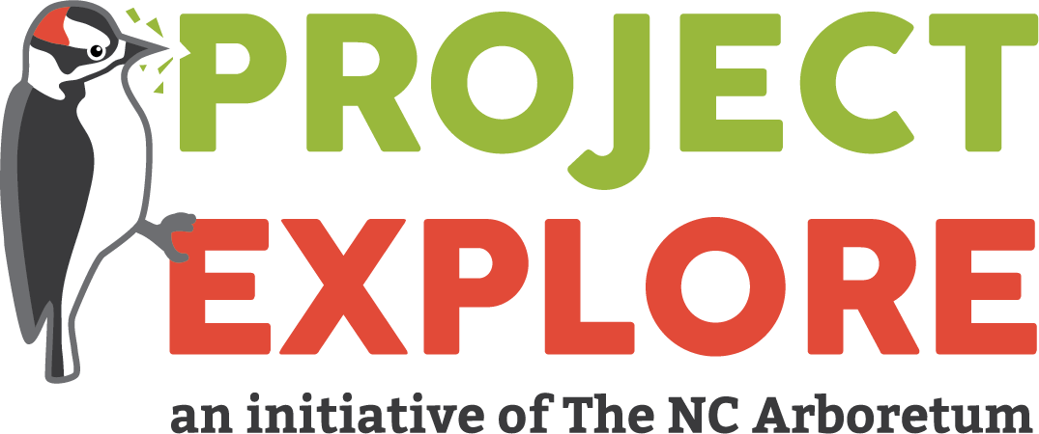

Project EXPLORE Mini Grant Application
Please email to projectexplore@ncarboretum.org

Due Date: August 23, 2021
“Project EXPLORE: Experiences Promoting Learning Outdoors for Research and Education”, will engage students at their schoolyard in two free, environmental educator-led science programs based on current science curriculum standards. Students will be engaged in ongoing data collection at their schoolyard, and will be invited to present their research.
Benefits to Teachers Admitted to Project EXPLORE include:
- A stipend of $100 toward the cost of materials and equipment for their chosen project;
- Loan of additional science education equipment for student use; After two years participation teachers will be awarded a set of classroom binoculars and/or hand lenses and datasheets to keep;
- A total of two guided lessons at the teacher’s schoolyard led by an Project EXPLORE Coach to aid in facilitation of a citizen science project;
- A winter check-in visit from a Project EXPLORE coach to go outside and collect data with you and your students to help answer any questions that may arise;
- And a certificate after 2 years participating in Project EXPLORE

Teachers will be committing to taking their students outside for at least 15 minutes a week to collect data and reporting data collected back to Citizen Science Project Coordinator. Programs will focus on providing information on the local flora and fauna of our region, understanding of the scientific method, collection of natural science data, and submission of data to professional scientists for review and interpretation.

Applicant Information
Name of applicant(s) Please include all names if multiple teachers from the same grade level are applying:
Click here to enter text.
Phone: Click here to enter text. | Email(s): Click here to enter text.
School: Click here to enter text.

School address: Click here to enter text.
Your mailing address (where you would like the award money to be sent):
Click here to enter text.
County: Click here to enter text.

Which subject(s) do you teach?
Click here to enter text.
Grade(s):
Click here to enter text.
Number of participating classes and students:
Click here to enter text.
Please share which days of the week your class or classes are available (to the best of your knowledge).
Click here to enter text.
How did you hear about Project EXPLORE?
Click here to enter text.

Application continued on next page.

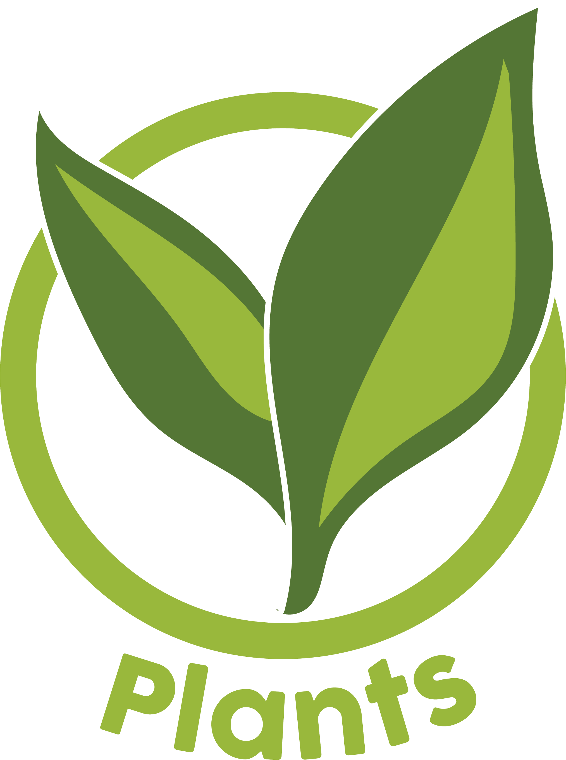
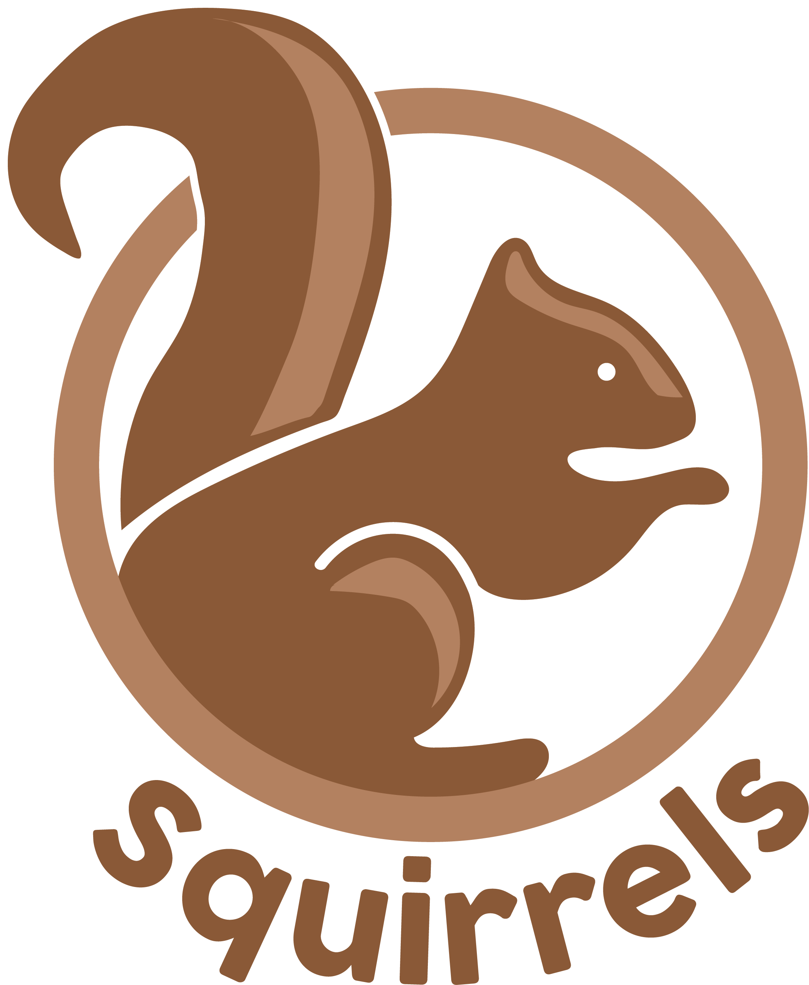
Project EXPLORE Mini-Grant Application
1. Which Citizen Science Project are you interested in? Please number 1-3 (1 being the most interested and 3 being the least interested).
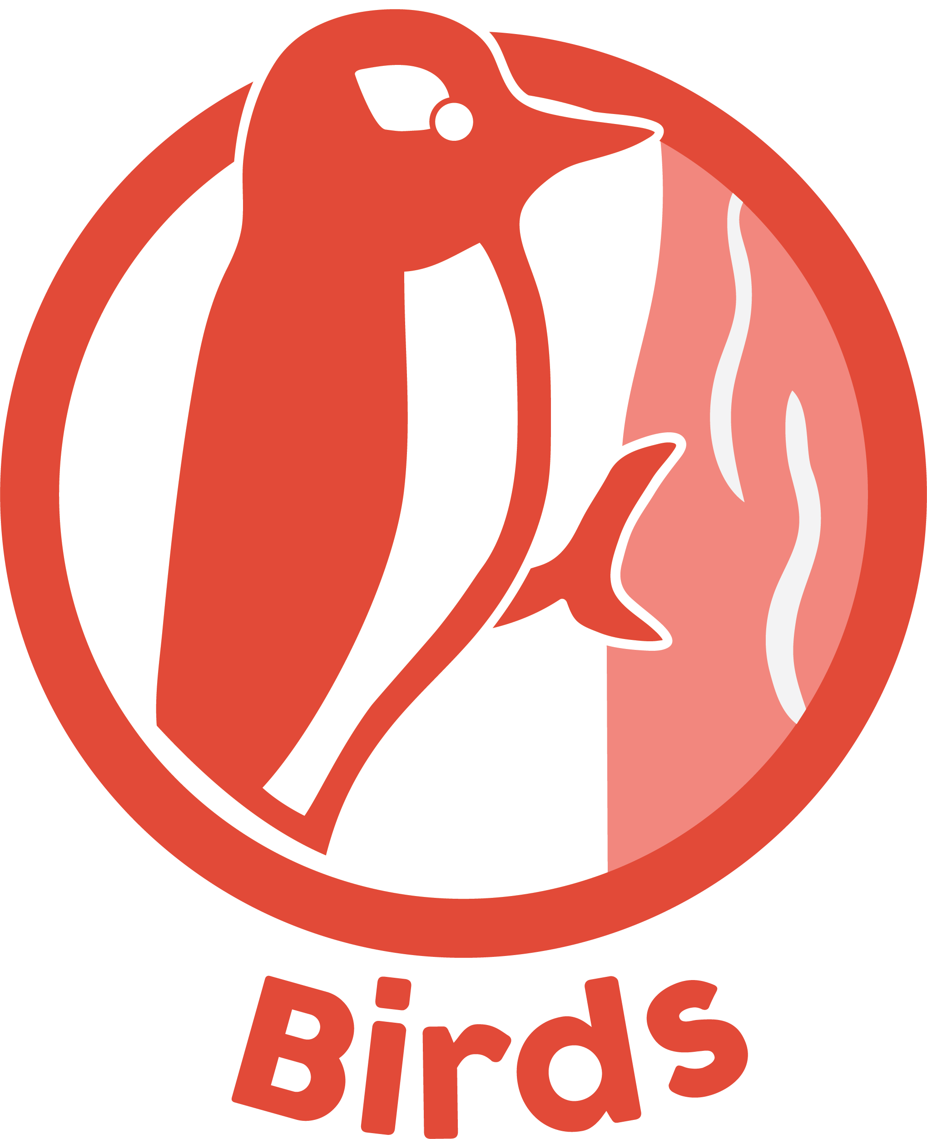

Project eBird Choose a number.
Project eBird is a citizen science project created by the Cornell Lab of Ornithology. Students will participate by learning how to identify bird species, collecting data about the birds they observe in their schoolyard, and sending the information to scientists who study bird populations and conservation. Students will have access to dynamic maps and graphs.
Suggested Materials: Bird feeder, bird seed, bird field guides, clipboards, (binoculars will be available for loan from TNCA)
Project Squirrel Choose a number.
Project Squirrel is a long-term study that partners with citizen scientists to collect broad-scale, fine-resolution data about squirrel population density, diversity, and behavioral characteristics. These data can then be interpreted by researchers (and citizen scientists) who wish to learn more about local and regional ecology. Students will hike around their schoolyard taking counts of the number of gray squirrels they observe and identifying tree types. Students will also have the option to study Giving Up Densities, a measure of how much risk squirrels are willing to take to forage for food. Classes will set corn or sunflower seed foraging patches in strategic areas of their school yard and measure the leftover food to determine the Giving Up Density of each patch.
Suggested Materials: Sunflower seeds, 300-g balance, cardboard squares, sand, sieve, clipboards, (binoculars will be available for loan from TNCA)
National Phenology Network Choose a number.
Phenology is nature’s calendar—when cherry trees bloom, when a robin builds its nest and when leaves turn color in the fall. The US National Phenology Network analyzes the timing of these annual events in the context of weather events and seasonal changes. This project involves a study of the different phases of trees by monitoring select trees in your schoolyard and recording when they flower, fruit, drop leaves, etc.
Suggested Materials: Tree field guides, clipboards, densitometers, (binoculars will be available for loan from TNCA), rulers or measuring tape
Other (please describe on a separate sheet of paper and include any necessary materials)
Application continued on next page.
Project EXPLORE Mini-Grant Application
1. Please explain why you want to participate in Project EXPLORE and how this program will benefit your curriculum

2. How do you plan to serve underserved populations by participating in Project EXPLORE? (Including minorities, low-income families, students of low academic achievement, students with disabilities)

Application continued on next page.

Project EXPLORE Mini-Grant Application
By applying for this grant you understand that if you are accepted you are committing to:
- Weekly collection of data during project time determined by teacher and Project EXPLORE Coach (minimum 15 minute study per week, not required during school holidays).
- Reporting data collected back to the Project EXPLORE Coach.
- Completing Pre and Post Teacher and Student Surveys (grant funding requirement)
Signature: Click here to enter text.
__________________________________________________

Please email application to:
projectexplore@ncarboretum.org
Due Date: August 23, 2021

